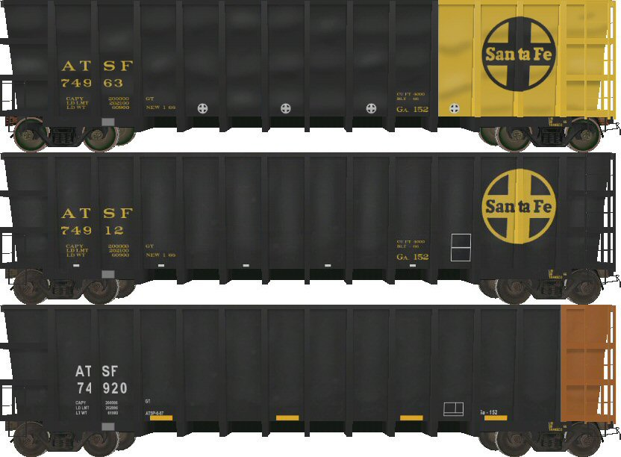
Santa Fe GA-152 “Kaiser Coal” Gondolas
By Matt Doti
(SouthwestChief on the Train-Sim.com Forums)
Email SouthwestChief@gmail.com

Shapes by Matt Doti and Ted Curphey
Textures by Matt Doti and Alan Hudson

Introduction and Features:

Thank you for downloading this set of Santa Fe gondolas. This is my very first 3D train car offering. I constructed these gondolas using Train Sim Modeler and textured the models with Paint Shop Pro 8.

For the trucks and couplers I used Ted Curphey’s outstanding shapes. I’m grateful that Ted is willing to share his work to help make our models look better.

Alan Hudson was an enormous help with updating the textures by adding realistic detailing such as shadows, and metallic reflections. Thanks Alan for making these good models into great models.

The custom and prototypical physics are compliments of Dan Zollner. My beta testers for this project included Herb Kelsey, John Reagon, and Alan Hudson. Thanks for all the help guys

Included with this set are a total of six gondolas, consisting of one loaded and one empty for each of the three paint schemes.

The yellow and black cars (numbers 74899 and 74963) are suitable for 1966 to the late 1970’s. The all black cars (numbers 74912 and 74950) are suitable for the early 1980’s. The black and orange cars (numbers 74920 and 74957) are suitable from the mid 1980’s to the present. Note, gondola #74920 is technically listed as loaded although the load is only a few scrap ties.
How To Use:

Download the file and copy and paste the folder named, Santa Fe Ga-152 to your train sim trainset folder located at:
C:\Program Files\Microsoft Games\Train Simulator\TRAINS\TRAINSET

I incorporated aggressive levels of detail to help with frames per second. However, because these cars use highly detailed trucks and couplers, I do not recommend running more than 40 cars per train if you have an older computer.

Legal Information:

These freight cars must be downloaded “as is” and “at your own risk”. I am in no way, nor is Train-Sim.com, or anyone else involved with this project responsible for any problems this download may cause to your computer. This download contains no warranties, be they implied, express, or warranty of title.

The new shapes contained in this download are my creation. The textures are a combination of Alan Hudson and my work. The trucks and coupler shapes and most of the texture they use are the work of Ted Curphey. Please do not redistribute these files for a fee.

Prototype Information:

The Santa Fe Ga-152 gondolas were constructed in 1966 by the Transco Rail Car company. These gondolas were specifically built for the Kaiser unit coal trains that traveled from the York Canyon mine in New Mexico to the Kaiser steel plant in Fontana California. Below is an excerpt from the Santa Fe Historical and Modeling Societies magazine, The Warbonnet Second Quarter 2004.

“September 28, 1967 … marked the beginning of regular service of the Santa Fe’s new unit-train operating over the 1,082 miles between the mine and Kaiser’s plant at Fontana. This train would carry 8,400 tons of coal from the mine to the mill and return covering the 2,164-mile round trip every four days – the longest precision scheduled unit train in the nation moving over a single railroad, and the first unit-train operating in the West. To provide this service, Santa Fe had acquired 101 specially-designed, black and yellow 100-ton gondola cars, costing $1.5 million, and 11 new diesel locomotives at a cost of $2 million.”

The unit train consisted of 84 gondolas and typically 9 locomotives. The Santa Fe successfully implemented Locotrol remote controlled helpers on this train. The motive power in the early years typically included Alco RSD15’s and EMD SD24’s, SD26’s, and SD39’s. As the years progressed so too did the locomotives that pulled this train. For suitable MSTS locomotives, I would suggest the Santa Fe SD24 by 3DTrains, as well as the “low nose” Santa Fe Alco RSD15 by Great North Rails.

The EMD SD24 can be found here:
http://www.3dtrains.com/downloads/trainsets.shtml

The Alco RSD15 can be found here:
http://www.greatnorthrails.com/addonsloco.htm

The Ga-152 gondolas did not have hatches on the bottom of the car and could only be unloaded via a rotary dumper. Although the cars were modern for their time, the large outside bracing ribs made for very poor aerodynamics. In fact, these gondolas still hold the record for least fuel efficient car in the entire Santa Fe fleet

The as delivered yellow and black paint scheme changed in the early 1980’s to a much simplified all black scheme. Around this same time, the Kaiser steel mill in Fontana closed down. It was inevitable that, in the already smoggy Los Angeles region, burning this much coal for a steel mill would have to end at some point.

With the end of dedicated coal service, the Ga-152 cars were put to use as needed. The short lived all black paint scheme was altered again to the present day orange and black some time in the mid to late 1980’s. The surviving cars are currently used by the BNSF mainly in work train service hauling wooden ties.

Resources:

Following is a list of resources I used for this project:

The Warbonnet, Second Quarter 2004
“Modeling EMD SD24’s, Shadow-lined passenger cars, Kaiser Coal Trains”

Santa Fe Heritage, Volume 1, By Stephen & Cinthia Priest
“Page 176 and 177, Ga-152”

Following are internet links if you are interested in obtaining the above resources:
http://www.atsfrr.net/store/war-Vol10.htm

http://www.pairedrail.com/books.html

Closing:

I hope you enjoy these Santa Fe gondolas. They are my first 3D train cars for MSTS. I’m grateful to all the friends that helped me with shapes, texturing, physics, and testing.

This was a long and tedious project and I learned much along the way. I encourage you to try 3D modeling. Now that I’ve completed one model, I hope to offer more Santa Fe items as the years progress. Santa Fe All the Way!

